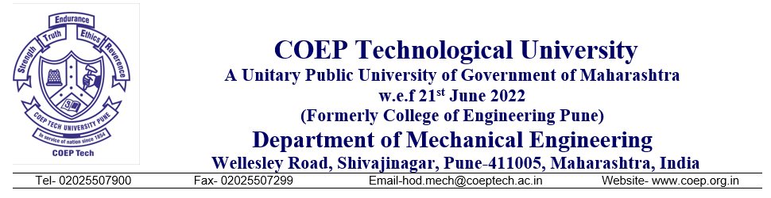
Enquiry Letter
Sealed quotations are invited by the Department of Mechanical Engineering, COEP Technological University, Pune, from reputed vendors, resellers, suppliers, and service providers for the painting of the external surfaces of G.I. ducts connected to industrial air coolers at the Experiential Lab as per description mentioned in table 1 and 2.

Table 1: Painting Work Description as per SSR 2023-24.

Sr. NO. | Code Item Code | Item Name | Description | Unit
1 | 35.07 – BDO 5  Ref: Page 200 of SSR 2023-24 | Two coats of synthetic enamel on structural steel / metal | Providing and applying two coats of synthetic enamel paint of approved color to new/old structural steel work and woodwork in buildings, including scaffolding if necessary, cleaning and preparing the surface (excluding primer coat) etc. complete. | Sq. m
2 | 35.20 – BDO 8D  Ref: Page 201 of SSR 2023-24 | Priming coat on new steel / metal surfaces | Providing and applying priming coat over new/old steel and other metal surfaces including preparing the surface by thoroughly cleaning oil, grease, dirt and other foreign matter and scoured with wire brushes, fine steel wool, scrappers and sand paper, scaffolding etc. complete. | Sq. m

Table 2: Invitation Of Quotation Schedule.

Enquiry Number :- | COEPTU/MECH/HVAC/Duct_Painting/2026-27/343-A
Enquiry Date: | 25/08/2026
Description & Qty:-  (Use This Table  format on your letter  head to submit  Quotation)
  Sr. No. | Items | Unit | Quantity (Nos.) | Rate  (Rs) | Cost  (Rs)
  1. | Experiential Lab air ducts. | Sq . m | 480
  2. | Overhead charges including scaffolding if any. | Sq . m | -
  3. | Transportation and any other remaining charges. | Nos. | 1
   | Sub-Total (Rs)
   | GST18% (Rs)
   | Total (Rs)
Location:- | Experiential Lab Academic complex.
Quotation Submission  Date@ Time:- | Up to 02/09/2026 @ 5.00pm
Quotation Submission  Place:- | Inward Section Establishment Department  COEP Technological University, Wellesley Road,  Shivajinagar, Pune-411005
Quotation Opening  Place:- | Head, Department of Mechanical Engineering,  COEP Technological University, Wellesley Road,  Shivajinagar, Pune-411005

Terms & Conditions:-
- Fax and Email quotation are not acceptable.
- The rates shall be valid for 90days.
- Validity: Quotation Validity at least 90 days from the due date.
- Quotations shall be sent in sealed envelopes clearly marked Quotation for painting of the external surfaces of G.I. ducts connected to industrial air coolers at the Experiential Lab, Enquiry Number, Enquiry date and Enquiry due date, addressed to The Head, Department of Mechanical Engineering, COEP Technological University Pune 411005.
- 100% payment will be paid after satisfactory delivery, installation and commissioning/work.
- Please specify the make and model of the item.
- Quotation(s) received after last date of Quotation submission will be rejected.
- Delivery/Work Period and Terms Conditions should be mentioned clearly.
- Delivery/Work: The penalty conditions are applicable for late delivery as per Government norms.
a) at the rate of 0.5 % per week; maximum limit of 10% shall be charged in case of PO value is less than 2 Lakh.

OR
b) at the rate of 0.5 per week; maximum limit of 5% shall be charged in case of PO value is 2 Lakh and above.
- All following documents/certificates should be provided / attached at the time quotation submission.
a) Shop Act License/Incorporation Certificate/Firm Registration Certificate Copy. b) PAN Card Copy
c) GST Certificate Copy
- COEP Technological University reserves the right to increase or decrease the quantity of the quoted items as per its requirements. The bill shall be prepared and paid at the finalized rates, for the actual quantity ordered.
- Supply/Work and Installation: - Vendor shall be responsible for successful installation, commissioning and testing of the supplied items at Experiential lab, COEP Technological University Pune-411005. Any defective component/device will be replaced by vendor at his cost.
- The Registrar of COEP Technological University Pune reserves right to reject any one or all the quotation(s) without assigning any reasons there for.

S/d-
Head
Department of Mechanical Engineering
COEP Technological University

