COEP Technological University, Pune
Hostel Allotment Notice DSY A.Y. 2026-27
- Room Allotment is scheduled on 09/08/2026 at 5:00 p.m. at Fusion Mess (Boys) and Saee Mess (Girls).
- Students allotted hostel accommodation must report and claim their allotted seat by paying the prescribed Hostel Admission Fee and Hostel Deposit on or before 11/08/2026, up to 6:00 p.m.
- Students failing to report and complete the payment within the stipulated date and time shall forfeit their claim to the allotted hostel seat.
- Payment link : https://onlinesbi.sbi.bank.in/sbicollect/payment/listcategory.htm
- For any queries: email: hostel@coeptech.ac.in

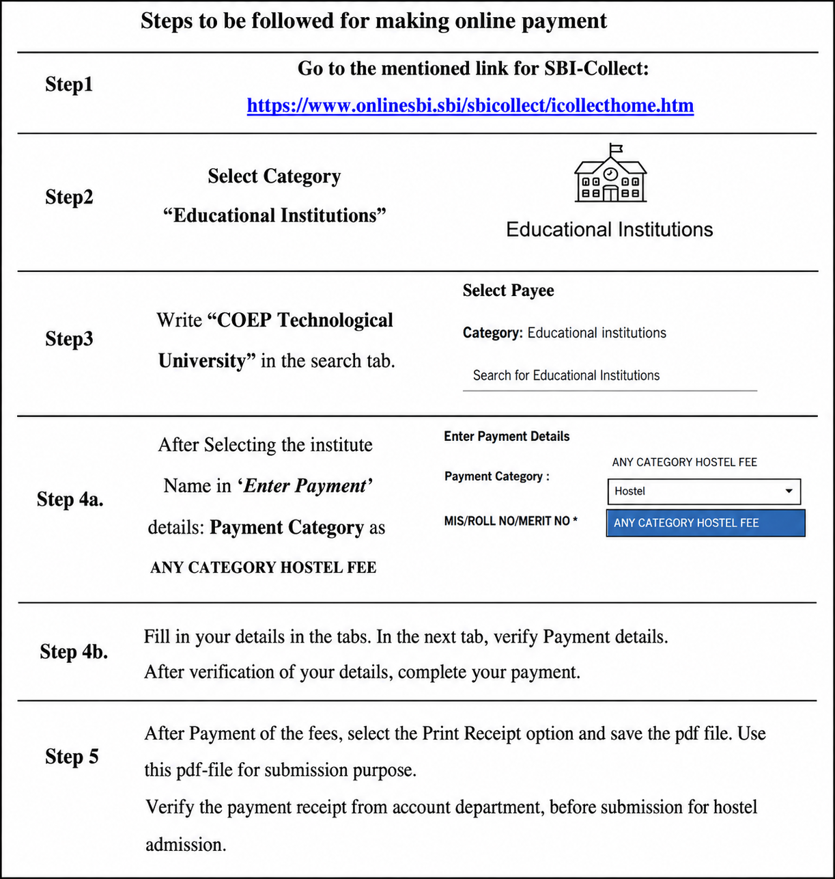
https://onlinesbi.sbi.bank.in/sbicollect/payment/listcategory.htm

